Social Participation Among Rural People For Sustainable Health, Nasirabad celebrated World Disabilities Day on 4th Dec. 2024 at Pisangan Panchayat Samiti’s stadium. The theme for the day was as prescribed i.e ‘Inclusion matters : access and empowerment of people of all abilities.’ At the function all PRI members of Peesangan panchyat samiti along with the education department (SSA) were invited. The purpose of the celebration was to make all the persons with disabilities along with the block level officers aware about the rights and inclusion matters i.e. accessibility and empowerment is a basic right of persons with disabilities as all human being has.
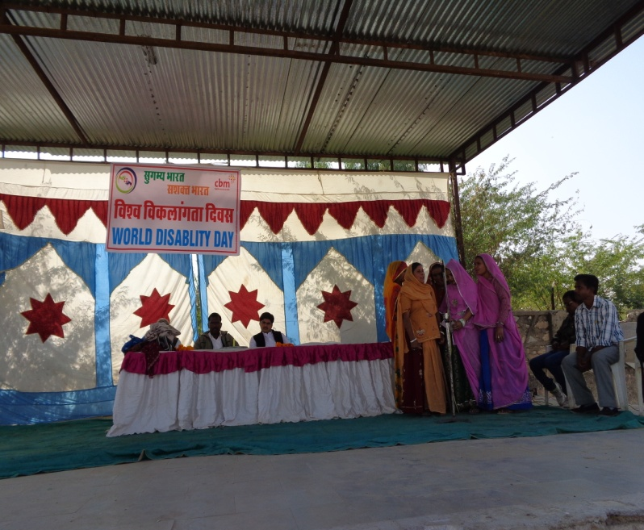
All the officials were welcomed with a garland and by a welcome song and dance were performed. Thereafter, organization’s staff Mrs. Elvina and Poonam Chand ji explained all the efforts made by the organization for person with disabilities. Importance of DPOs and what and how DPOs have changed their life
Then Mr. Amit Solomon of the organization explained the reason for celebrating this day i.e World Disability Day in order to get person with disabilities equal rights and equality in the society. He explained that today also there are many places where person with disabilities are not accessible due to which there is lack of awareness among them or they do not gain complete and correct information. Therefore, they are unable to enjoy their rights, benefits of government schemes, etc. So person with disabilities are required to unite themselves and fight for their rights.
Thereafter, DPO leader told about the changes that came in their and other group members’ life after joining the DPO. Mrs. Meena Kawar (locomoter disability) told that she assisted other women in getting their loans, medical forms filled and submission in their respective departments for their small entrepreneurship. She told that a disabled woman can also do all the same basic jobs as a normal woman can do.
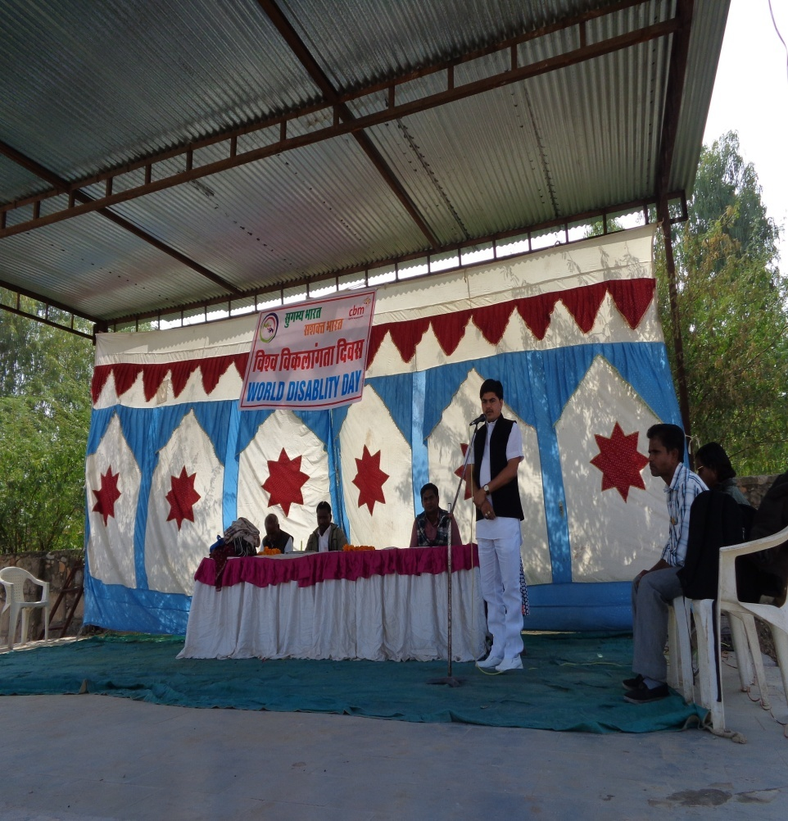
Shri Dilip Pachaar, Prdhan of Pisangan Panchayat Samiti appreciated the efforts made by the organization in the block. He also promised to get rid of the barriers which hurdle the person with disabilities and stop them enjoying their rights and becoming independent. He said that - ‘It made me feel proud that so much effort are being made in this Pisangan block for the development of Person with Disabilities. Inclusion is a must to bring them all at the same platform. Many of them are empowered and other will be too’.
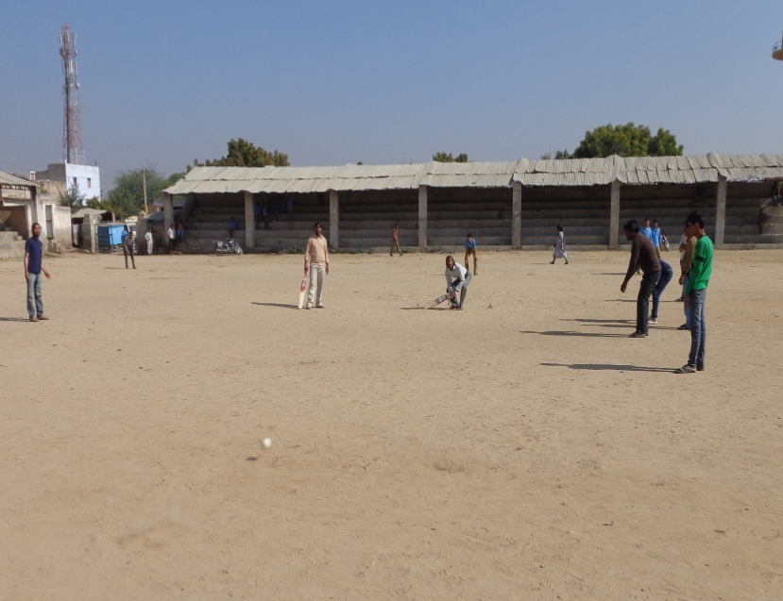
One of the DPO leader Shri Rajendra Jatak (visually impaired) told how he had formed a DPO within his village and what all activities they are doing .Thereafter, a cricket match was played by all the visually impaired people .They all played well and the public enjoyed it and learned that Person with Disabilities can also do great things. In the end prize and gifts were distributed to the winning team and all the participants along with the DPO leaders in order to motivate for their good efforts.
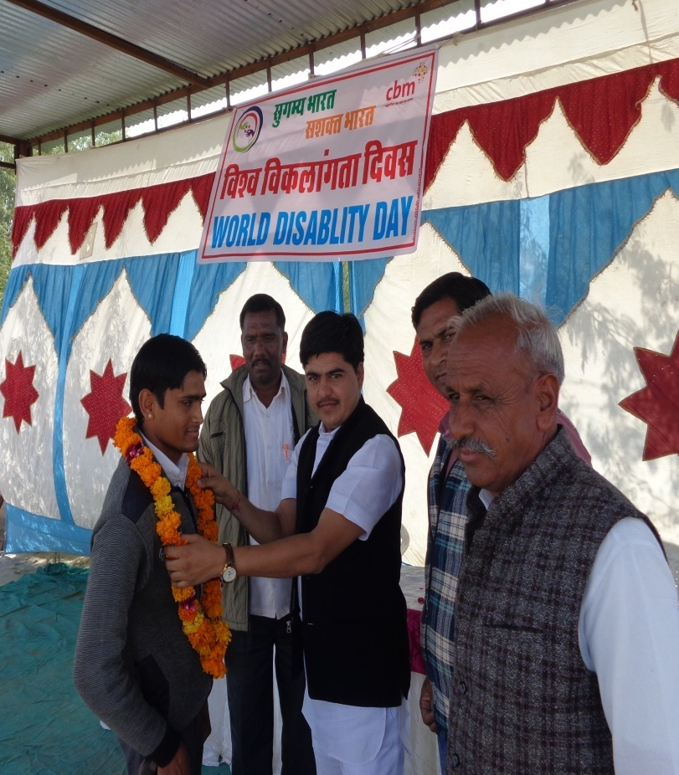
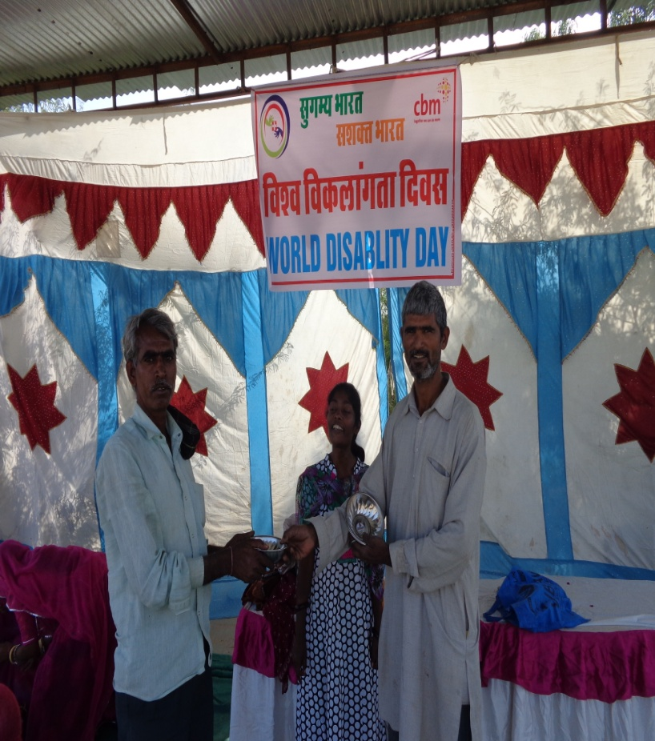
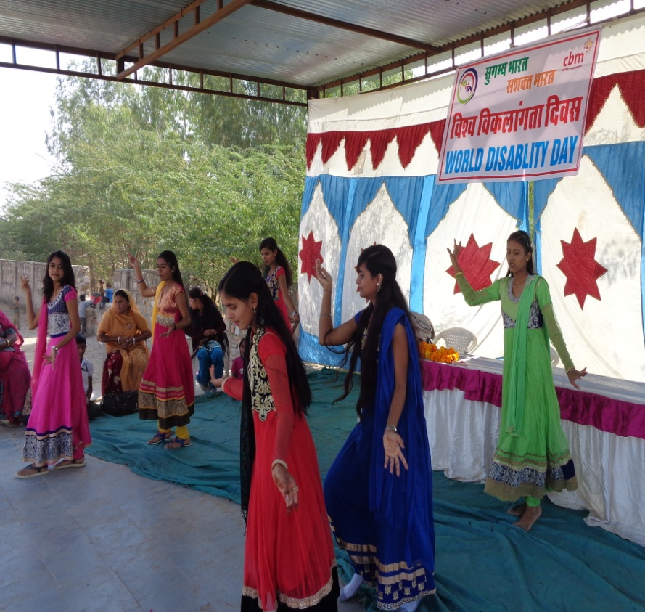
Other Photographs:

